**Project Plan**

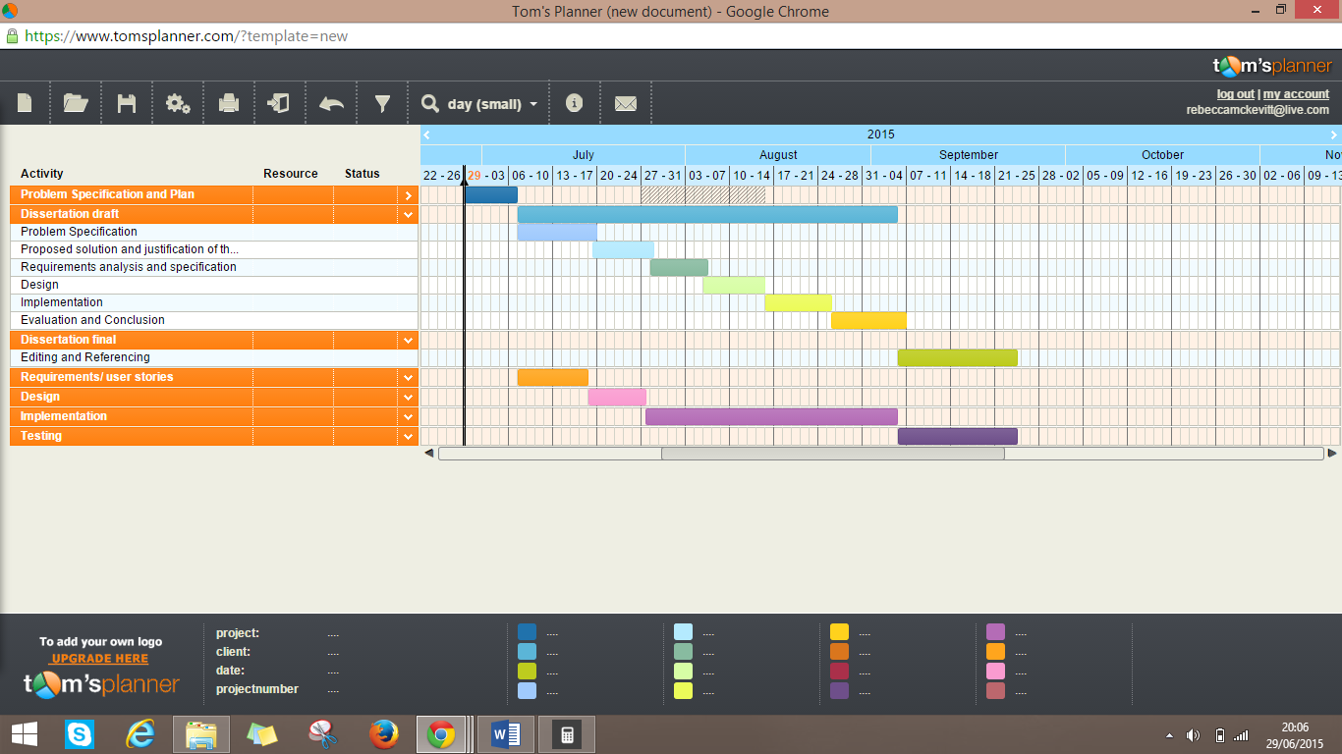This project will follow the waterfall model however there will be iterations as these dates are more a guide to measure progress. As testing will commence from analysing the requirements and design to testing the implementation.